**Lecture Agenda:**

1. How Represnt an Image?
2. Types of Image?
3. What is imaging ? types of Iaging./ Difference between Active image /Passive Image.

## Dimensions of image.Different dimensions of signals

# Grayscale to RGB Conversion

# Concept of Pixel

# Difference between Image Sampling and Quantization.

1. Image Coordinate System
2. What is Image File Formats?
3. Human Vision System.

* How Represnt an Image?

A digital image is different from an analog image. Computers do not process the images like our eyes. They use pixels to store information in quantized form. The pixels are stored in an array-like fashion in rows and columns. Each pixel contains information about the image in the form of integers. The integral values define the color composition of the pixel.

* Types of Image?
* What is imaging ? types of Iaging./ Difference between Active image /Passive Image.

Imaging means “image ***acquisition***”

*The process of sensing our surroundings and then representing the measurements that are made in the form of an image.*

* Imaging can be ***active*** or ***passive***
  1. **Passive**: No external source is required. Uses the energy sources already present in the scene.
     + Cameras without a flash
     + Night vision goggle
  2. **Active**: External source is required.
     + MRI
     + X-Rays
     + Radar
     + Scanner
     + Cameras with a flash

## **Dimensions of image.Different dimensions of signals.**

* Image dimensions have the length and width of a digital image.
* It does not have depth. An image is measured in pixels.
* An image is only of 2-dimensional that is why an image is defined as a 2-dimensional signal.

## **Different dimensions of signals:**

#### **1-Dimension Signal**

A noisy voice signal is an example of 1 dimension signal. In maths, it can be represented as:

1. F(x)=waveform

As it is a 1-dimension signal that is why one variable is used.

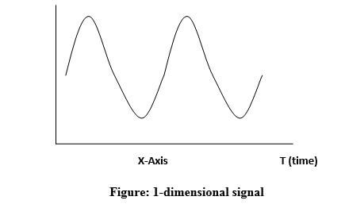

A question arises here that as it is a one-dimensional signal then why it has two axes?

Even, it is a one-dimensional signal but drawn on two-dimensional space. Or we can say that to represent 1-dimensional signal we have used 2-dimensional space.

#### **2-Dimension Signal**

Any object which has length and height comes under 2-dimension signal. It has two independent variables.

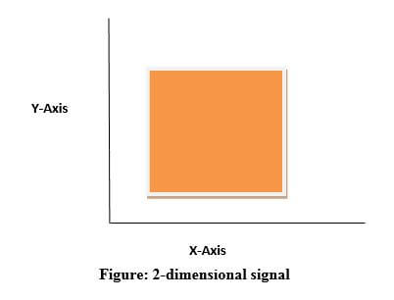

#### **3-Dimension Signal**

## Any object which has length and height and depth comes under 3-dimension signal. It has three independent variables:

## In math, it can be represented as:

## F (x, y, z) = Animated object

## Our earth is a 3-dimensional world. A cube is also an example of a 3-dimensional signal

## 

#### **4-Dimension Signal**

Any object which has length, height, depth and time comes under 4-dimension signal. It has four independent variables.

In math, it can be represented as:

1. F (x, y, z, t) = Animated movie

In reality, animated movies are 4D in which 3 dimensions are used and the 4th dimension is time. In animated movies, each character is 3D and moves with respect to the time.

# Grayscale to RGB Conversion:

To convert a grayscale image into color or RGB format, we have two methods.

## 1. Average method

It is the simplest method. We have to take an average of all the 3 colors.

**Formula:** (R + G + B)/3

**For example:**

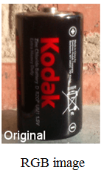 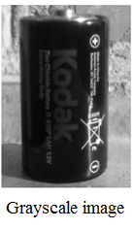

### Explanation

As we can see, there are changes in the image by applying the average method. But the result is unexpected as we want a grayscale image, but it turned to be a black image.

**Problem**

This problem occurs because we have taken an average of 3 colors. All the 3 colors have different wavelength and have their contribution to the formation of an image. In the above image, we are taking 33% from each portion that is why the image does not occur in grayscale.

The solution to this problem is given by the weighted method.

Let the new grayscale image be X

Grayscale to RGB Conversion

According to the above equation, red is used 30%, green is used 59%, and blue is used 11%. The contribution of green is highest.

# **Concept of Pixel**

* The full form of the pixel is "Picture Element."
* It is also known as **"PEL."**
* **Pixel is the smallest element of an image on a computer display, whether they are LCD or CRT monitors.**
* **A screen is made up of a matrix of thousands or millions of pixels.**



**Calculation of the total number of pixels**

**Below is the formula to calculate the total number of pixel in an image.**

**Concept of Pixel**

**For example: let rows=300 & columns=200  
Total number of pixels= 300 X 200  
 = 60000**

# **Difference between Image Sampling and Quantization.**

# To create a digital image, we need to convert the continuous sensed data into digital form. This process includes 2 processes:

# **Sampling:** Digitizing the co-ordinate value is called sampling.

# **Quantization:** Digitizing the amplitude value is called quantization.

# To convert a continuous image f(x, y) into digital form, we have to sample the function in both co-ordinates and amplitude.

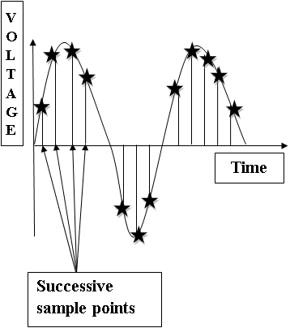

## 

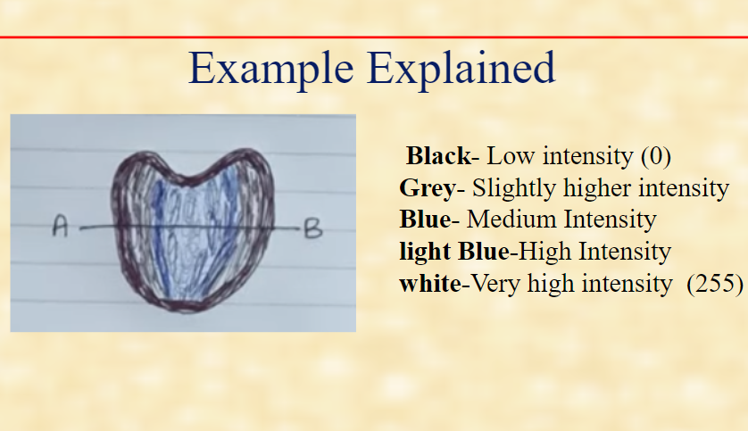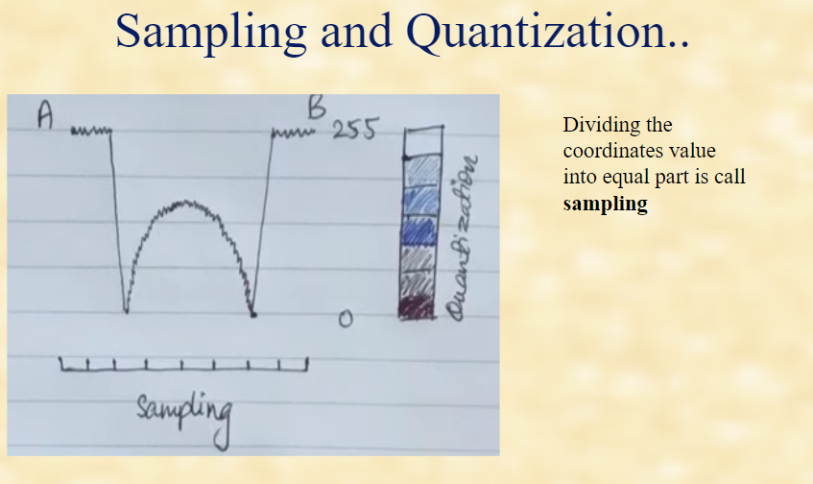

## Oversampling

As we have seen above, there are two types of sampling, up-sampling, and down-sampling.

Up-sampling is also known as oversampling.

In an image, oversampling means using a high-resolution image sensor as compare to camera output image resolution.

One of the oversampling applications in image processing is known as **zooming.**

|  |  |
| --- | --- |
| **Sampling** | **Quantization** |
| **Digitization of co-ordinate values.** | **Digitization of amplitude values.** |
| **x-axis(time) – discretized.** | **x-axis(time) – continuous.** |
| **y-axis(amplitude) – continuous.** | **y-axis(amplitude) – discretized.** |
| **Sampling is done prior to the quantization process.** | **Quantizatin is done after the sampling process.** |

**###Image Coordinate System**

**An image coordinate system defines the spatial reference in terms of a primary image.**

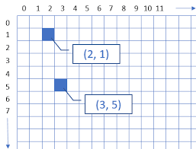

**###What is Image File Formats?**

**Image Format describes how data related to the image will be stored.**

Magic Number|| Header|| Pixel Data (in some format … perhaps compressed)

* **TIFF(.tif, .tiff)::** Tagged Image File Format this format store image data without losing any data.a high-quality image is obtained but the size of the image is also large, which is good for printing, and professional printing.
* **JPEG (.jpg, .jpeg)::**Data is lost to reduce the size of the image. Due to compression, some data is lost but that loss is very less. It is a very common format and is good for digital cameras, nonprofessional prints, E-Mail, Powerpoint, etc., making it ideal for web use.
* **GIF (.gif)** GIF files are typically small in size and are portable.

**Human Vision System(HVS):**

**In human visual perception, the eyes act as the sensor or camera, neurons act as the connecting cable and the brain acts as the processor.**

**The basic elements of visual perceptions are:**

1. **Structure of Eye**
2. **Image Formation in the Eye**
3. **Brightness Adaptation and Discrimination**

**Structure of Eye:**

* The human eye is a slightly asymmetrical sphere with an average diameter of the length of 20mm to 25mm.The eye is just like a camera.
* The external object is seen as the camera take the picture of any object.
* Light enters the eye through a small hole called the pupil, a black looking aperture having the quality of contraction of eye when exposed to bright light and is focused on the retina which is like a camera film. The lens, iris, and cornea are nourished by clear fluid, know as anterior chamber.
* Cones in eye number between 6 to 7 million which are highly sensitive to colors. Human visualizes the colored image in daylight due to these cones. The cone vision is also called as photopic or bright-light vision.
* Rods are not involved in the color vision and are sensitive to low levels of illumination.

**Image Formation in the Eye:**   
When the lens of the eye focus an image of the outside world onto a light-sensitive membrane in the back of the eye, called retina the image is formed. The lens of the eye focuses light on the photoreceptive cells of the retina which detects the photons of light and responds by producing neural impulses.

* 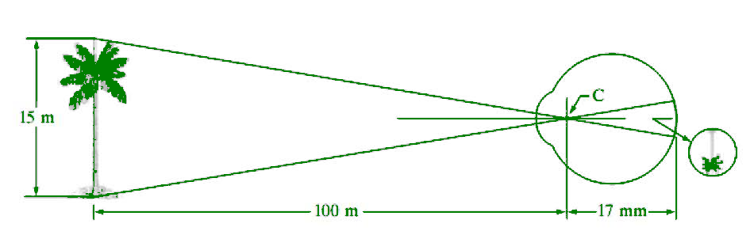
* The distance between the lens and the retina is about 17mm and the focal length is approximately 14mm to 17mm.

**Brightness Adaptation and Discrimination:**   
Digital images are displayed as a discrete set of intensities. The eyes ability to discriminate black and white at different intensity levels is an important consideration in presenting image processing result.

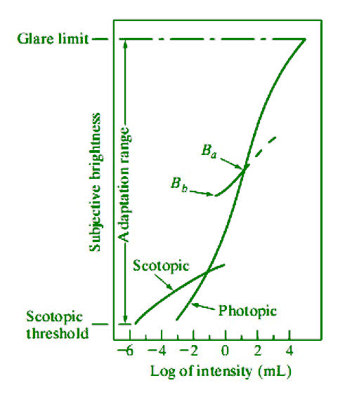

The range of light intensity levels to which the human visual system can adapt is of the order of 1010 from the scotopic threshold to the glare limit. In a photopic vision, the range is about 106.